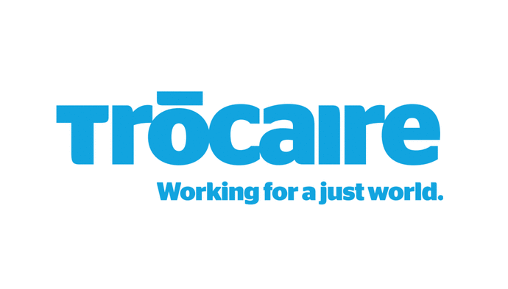
SUNDAY 23 NOVEMBER

Welcome to our Christmas Trocaire Event

Santa, stalls, ballot, tea & coffee, Christmas Fayre
Also Trocaire Christmas cards on sale.

Help Trocaire help those who face war, hunger and poverty

