August & September 2026 @ Lough Derg
A pilgrimage has a vital part to play in our life of faith, for it removes us from our daily routines, and gives us time and space to encounter God more deeply.
Pope Leo XIV

Three Day Pilgrimages – In the tradition of prayer, fasting and keeping Vigil
Begin on any day of the week until Thursday 13th August.
Admission €85. Discounts available for Groups, Seniors & Students.

One Day Retreats – Guided Days of Prayer and Reflection - places available on
August 18th, 22nd, 23rd, 29th and 31st
September 5th, 6th, 9th, 12th, 15th, 19th and 20th
Admission €50. Group discounts available. Advance Booking Essential .

Includes Special Themed Retreats:
23rd August - St Peregrine
5th September – Pioneer Pilgrimage
6th September – St Carlos Acutis
9th & 12th September – Vocations Monstrance
19th September – Divine Mercy Pilgrimage

Heritage Day Tours – Explore one of Ireland’s most enduring and authentic spiritual destinations. Thursday 20th August. 11am & 2:30pm
As part of National Heritage Week celebrations visitors will enjoy a guided boat trip on the lake, guided tour of Station Island and refreshments.
Admission €15. Student & Child discounts available. Advance Booking Essential.

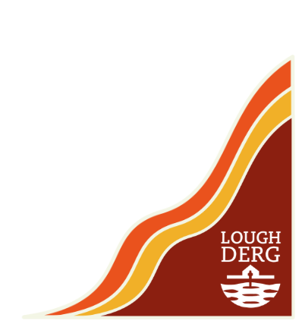
Lakeshore Pilgrim Path Pilgrimage – In the footsteps of pilgrims through the centuries
Sunday 30th August. 8km & 12km routes, fully guided. Outdoor Mass weather permitting.
Admission €25. Advance Booking Essential.

NEW FOR 2026 SEASON –Overnight accommodation available on Station Island the night before beginning a Retreat or Pilgrimage.

Lough Derg, Pettigo, Co Donegal. F94 PC60
www.loughderg.org email. info@loughderg.org Tel. 0719861518

