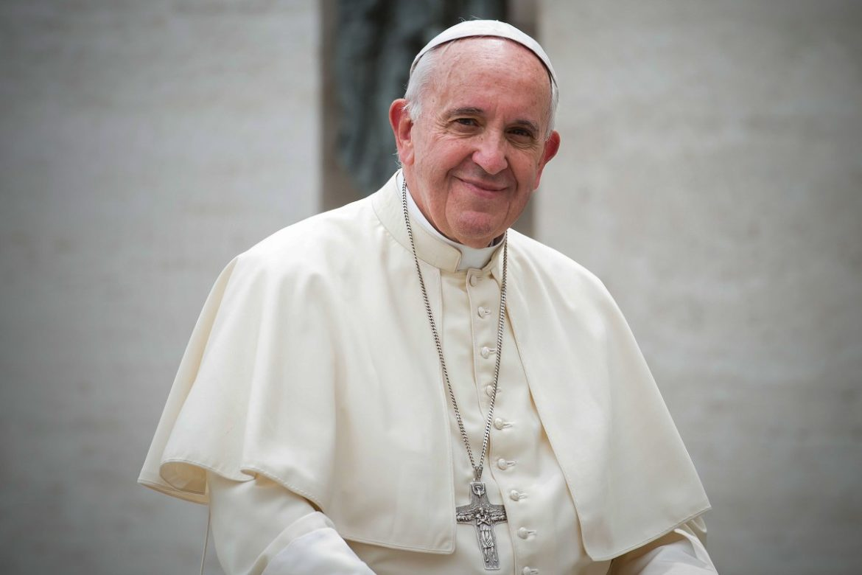

INVITATION OF THE HOLY FATHER TO
A DAY OF PRAYER AND FASTING FOR PEACE
(General Audience, 18th October 2023)

“Today too, dear brothers and sisters, our thoughts turn to Palestine and Israel. The number of victims is rising and the situation in Gaza is desperate. Please, let everything possible be done to avoid a humanitarian disaster. The possible widening of the conflict is disturbing, while so many war fronts are already open in the world. May weapons be silenced, and let us heed the cry for peace of the poor, the people, the children… Brothers and sisters, war does not solve any problem: it sows only death and destruction, foments hate, proliferates revenge. War cancels out the future, it cancels out the future. I urge believers to take just one side in this conflict: that of peace. But not in words – in prayer, with total dedication. With this in mind, I have decided to call for a day of fasting and prayer on Friday 27 October, a day of penance to which I invite sisters and brothers of the various Christian denominations, those belonging to other religions and all those who have at heart the cause of peace in the world, to join in as they see fit. That evening, at 18.00 at Saint Peter’s, we will spend an hour of prayer in a spirit of penance to implore peace in our time, peace in this world. I ask all the particular Churches to participate by arranging similar activities involving the People of God”.

