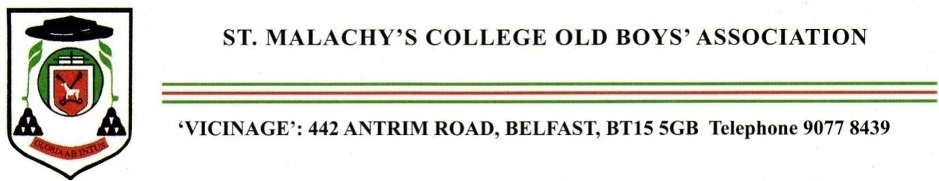
The
Annual Mass

for the happy repose of the souls
of deceased Old Boys
and members of staff
will be celebrated in the
College Chapel
on
Monday November 9th, 2026
at 7. 30pm.
Celebrant :

Very Rev Francis O Brien PP

St Patrick’s Parish, Belfast

