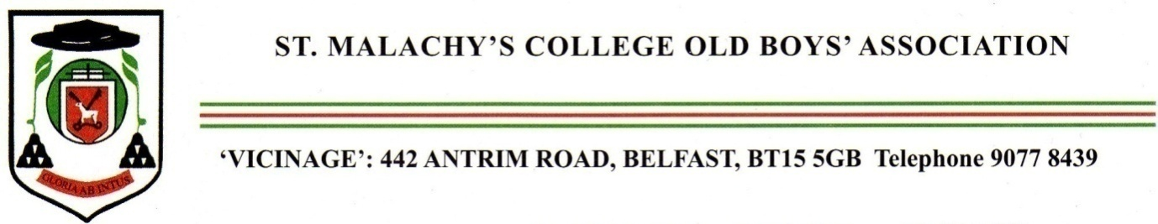
The
Annual Mass

for the happy repose of the souls
of deceased Old Boys
and members of staff
will be celebrated in the
College Chapel
on Monday November 13th, 2023
at 7. 30pm.
Celebrant :

Fr Martin Henry

Priest of the Diocese of Down and Connor, former Lecturer in Theology, St Patrick’s College, Maynooth

